The purpose of my website is to provide information about every green day release, titles, date of release, track lists, and more.

Some image ideas



Layout ideas:

Album layout:

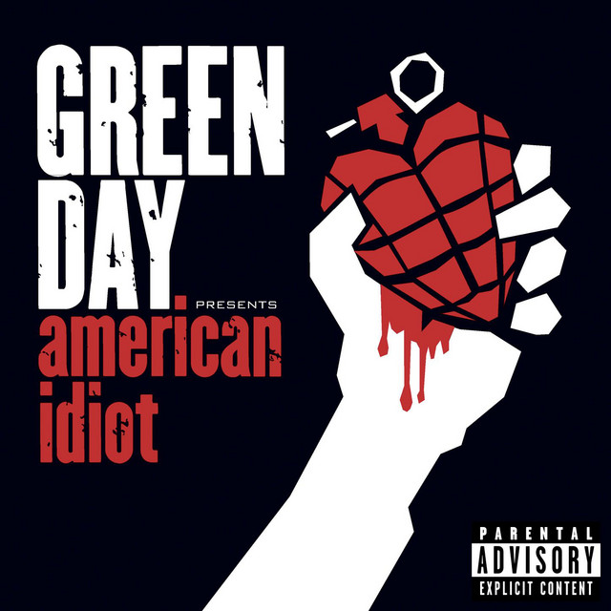

**Title:** American Idiot

**Date Released:** September 21st 2004

**Tracks:** 1. American Idiot

**Tracks:**  2. Jesus of Suburbia

**Tracks:**  3. Holiday/Boulevard of Broken Dreams

**Tracks:**  4. Are we the Waiting/St. Jimmy

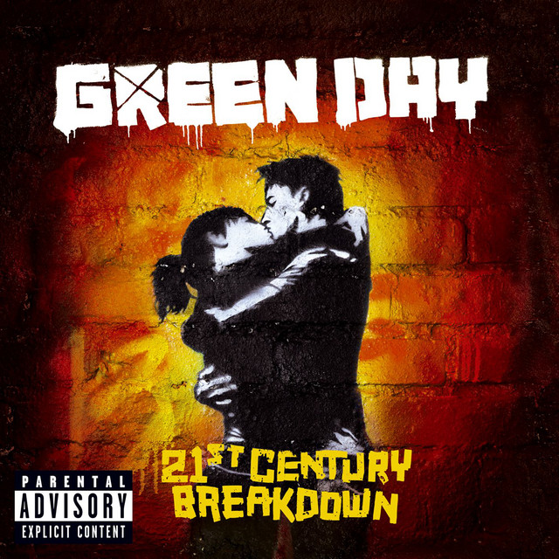

**Title:** 21st Century Breakdown

**Date Released:** May 15th 2009**a**

**Tracks:** 1

Date

**Tracks:**

Alternates between images on left and right

Album descriptions:

39/Smooth - Green Day’s debut album released on April 13th 1990 and sold around 75,000 copies by 1994. The album has 10 tracks and has a total runtime of 31 minutes and 12 seconds. This album is one of 2 albums produced by Green Day under the label Lookout Records.

Kerplunk! - Green Day’s second album was released on December 17th 1991. It sold 10,000 copies on the day of its release, and as of January 2017 has sold over 4 million copies. Tre Cool made his debut as Green Day’s drummer on this album after former drummer John Kiffmeyer left the band. The album has 12 tracks and has a total runtime of 33 minutes and 56 seconds.This was the last album released under the label Lookout Records.

Dookie - Released on February 1st 1994, “Dookie” was a smash success, selling out the pre-produced 9,000 copies on the day of its release, and has sold over 20 million copies worldwide, making it one of the best selling albums in history. Dookie made Green Day a staple name in the world of music and was the first album released by Green Day under the label Reprise Records. The first single released on the album was “Longview”, later followed by “Basket Case”, “Welcome To Paradise”, and “When I Come Around”. The album has 14 tracks and has a total runtime of 39 minutes and 35 seconds.

Insomniac - Green Day’s 4th album was released on October 10th 1995 and sold 171,000 copies in its first week. The album's first single was “Geek Stink Breath” followed by “Stuck With Me”, which was focused on the backlash that Green Day’s original fans had to them signing on with a major label, and “Brain Stew / Jaded”. The album has 14 tracks and has a total runtime of 32 minutes and 49 seconds.

Nimrod - Released on October 14th 1997, Green Day’s 5th album produced 4 singles, starting with “Hitchin’ a Ride” 2 weeks before the albums release, “Good Riddance (Time of Your Life)”, which has become the staple ending song of all their concerts, “Redundant” in 1998, and “Nice Guys Finish Last” in 1999. The first week of its release saw 81,000 copies released, and in 2000 was certified double platinum by the RIAA for selling over 2 million copies. The album has 18 tracks and has a total runtime of 49 minutes and 1 second.

Warning - Green Day’s 6th album released on October 3rd 2000 to mixed reviews. Despite selling 156,000 copies in its first week and peaking at number 4 on the billboard 200, it was the lowest commercial slump in Green Day’s career. As of 2025, it has sold 3.5 million copies worldwide. The album produced 3 singles: “Minority”, “Warning”, both released in 2000, and “Waiting” in 2001. The album has 12 tracks and has a total runtime of 41 minutes and 14 seconds.

American Idiot - American Idiot was released on September 21st 2004 and received largely positive reviews. The album sold 267,000 copies in its first week and as of August 2024, has sold over 23 million copies worldwide. In 2005, the album won a Grammy Award for Best Rock Album, and was nominated in 6 other categories, including Album of the Year. The album produced 5 singles: “American Idiot”, “Boulevard of Broken Dreams” which won a Grammy Award for Record of the Year in 2006, “Holiday”, “Wake Me Up When September Ends”, and “Jesus of Suburbia”. The album has 13 tracks and has a total runtime of 57 minutes and 12 seconds.

21st Century Breakdown - Released on May 15th 2009, 21st Century Breakdown debuted at number 1 on the Billboard 200 and sold 215,000 copies in its first week, and over 4 million worldwide as of 2010. The album produced 5 singles: “Know Your Enemy”, “21 Guns”, “East Jesus Nowhere”, “21st Century Breakdown”, and “Last of the American Girls”. The album has 18 tracks and has a total runtime of 69 minutes and 17 seconds, making it Green Day’s longest studio album to date.

Bullet in a Bible - Bullet in a Bible is Green Day’s first live album release. The album was recorded on June 18th and 19th, 2005 at the National Bowl in Milton Keynes, England as part of their American Idiot World Tour. Over the 2 day period, they played for over 130,000 people. The album has a total runtime of 64 minutes and 57 seconds.The CD version includes a DVD of the performance directed by Samuel Bayer, who was the director of all the music videos that came from American Idiot.

Awesome as Fuck - Green Day’s 2nd live album, Awesome as Fuck was recorded during the bands 2009-2010 21st Century Breakdown World Tour, and released on March 22nd 2011. The album includes a CD of live songs from all over the world, and a DVD of a show at the Saitama Super Arena in Japan. The unreleased song “Cigarettes and Valentines” was played on this tour, and appears on the CD. The album has a total runtime of 146 minutes and 56 seconds (including the DVD)

Woodstock 1994 - Woodstock 1994 is the 3rd live album by Green Day. It was released specially through Record Story Day on April 13th 2019, in honor of the 50th anniversary of Woodstock. This was the first live Green Day album to include the entire setlist. The album was very limited, and only available on vinyl, although it reappeared in the Dookie 30th Anniversary set in both vinyl and CD formats. The album has a total runtime of 38 minutes and 59 seconds.

BBC Sessions - BBC Sessions is the 4th and most recent live album released by Green Day. Released on December 10th 2021, it consists of live recordings for the BBC from June 1994 to August 2001 held at the Maida Vale Studios in London."One of My Lies" and "Scattered" from the 1998 session are the only songs not featured on the album. The album has a total runtime of 48 minutes and 27 seconds

1,039/Smoothed Out Slappy Hours - 1,039/Smoothed Out Slappy Hours is a compilation album released by Green Day through Lookout Records on October 1st 1991, despite the 1990 copyright date printed. The album is a compilation of the bands debut album “39/Smooth”, and their 2 EPs: “Slappy” and “1000 Hours”. The album has sold over 2 million copies worldwide, and has a total runtime of 56 minutes and 15 seconds.

International Superhits! - International Superhits is the first greatest hits compilation produced by Green Day. The album was released on November 13th 2001 alongside a DVD and VHS titled “International Supervideos!”, which compiled 15 of the band’s music videos spanning the same period. The album contains a rerecording of the song “Maria” from the B-side of “Waiting”, and a previously unreleased song “Poprocks & Coke”. The album has a total runtime of 60 minutes and 44 seconds.

Shenanigans - Shenanigans is the 3rd compilation album released by Green Day. The album was released on July 2nd 2002 and contains B-sides, rarities, covers, and the previously unreleased song “Ha Ha You’re Dead”. Some of the songs on the album have been in multiple movies, including “Espionage” appearing in “Austin Powers: The Spy Who Shagged Me”, and “Scumbag” appearing in “American Pie 2”. The album has a total runtime of 33 minutes and 23 seconds.

God’s Favorite Band - Greatest Hits: God’s Favorite Band is the 2nd greatest hits album released by Green Day. The album was released on November 17th 2017 and features 20 of the band's greatest songs at the time, including a new version of “Ordinary World” and a previously unreleased song “Back In The USA”. 10 of the tracks appeared on their 2001 greatest hits album “International Superhits!” The album has a total runtime of 75 minutes and 58 seconds.

¡UNO! - ¡UNO! is the 9th studio album released by Green Day. The album was released as the first in a trio of albums released on September 21st, November 9th, and December 7th 2012. In the first week, it sold over 139,000 copies. The singles on the album are titled “Oh Love”, “Kill the DJ”, and “Let Yourself Go”. The trio of albums were recorded with touring guitarist Jason White to give the albums a more live feel to them. The album has a total runtime of 41 minutes and 44 seconds.

¡DOS! - ¡DOS! is the 10th studio album released by Green Day, and the second released in their trio of albums released from September to December 2012. The album was aimed to have a more garage-rock sound than the pop-punk style of ¡UNO!. The album yielded only one single: “Stray Heart” which was released on October 15th 2012. The album sold over 69,000 copies in its first week and has a total runtime of 39 minutes and 21 seconds.

¡TRE! - ¡TRE! is the 11th studio album released by Green Day and the final piece in their trio of albums. The album mixes together the pop-punk style of ¡UNO! and the garage-rock style of ¡DOS! to make an epic sounding album. The album had 2 singles: “The Forgotten”, and “X-Kid”. In the first week, the album sold over 58,000 copies, and the trio of albums have sold over 780,000 copies worldwide. The album has a total runtime of 46 minutes and 35 seconds.

Revolution Radio - Revolution Radio is the 12th studio album released by Green Day. Released on October 7th 2016, the album was a self produced effort, marking the first time since “21st Century Breakdown” to not be produced by long time producer Rob Cavallo. The album produced 3 singles: “Bang Bang”, “Revolution Radio”, and “Still Breathing”. The album sold over 1,305,000 copies worldwide, and has a total runtime of 44 minutes and 40 seconds.

Father of all Motherfuckers - Father of all Motherfuckers is the 13th studio released by Green Day. It was released on February 7th 2020 and sold over 48,000 copies in its first week. The album was preceded by 3 singles: “Father of All…”, “Fire, Ready, Aim”, and “Oh Yeah!”. The album has been listed as the worst rock album of the 21st century. It has a total runtime of 26 minutes and 12 seconds, making it their shortest studio album to date.

Saviors - Saviors is the 14th and latest studio album released by Green Day. The album was released on January 19th 2024 and has since sold over 328,000 copies. The album was promoted through 5 singles: “The American Dream Is Killing Me”, Look Ma, No Brains!”, “Dilemma”, “One Eyed Bastard”, and “Bobby Sox”. The album was nominated at the 67th Annual Grammy Awards for Best Rock Album. The album has a total runtime of 46 minutes and 2 seconds.